BLMR CLOSURE - RIP

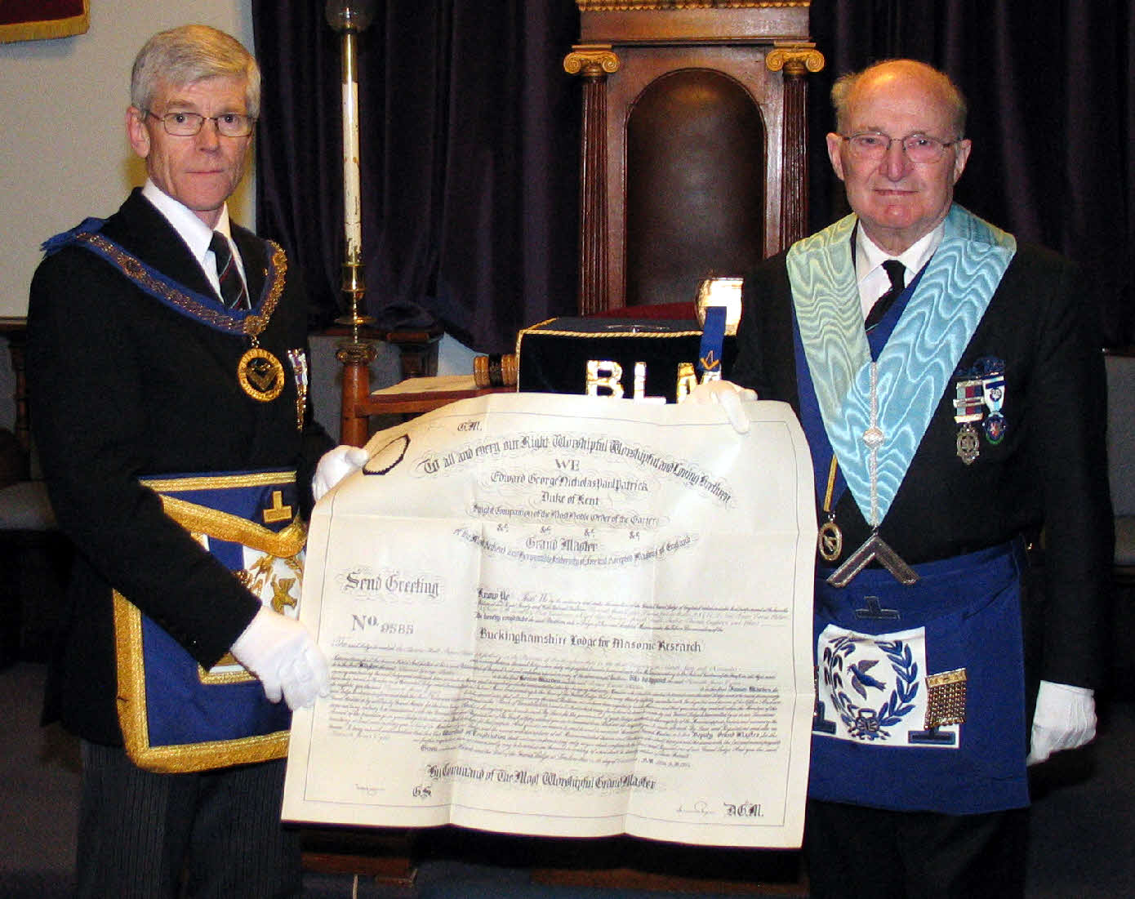
On Friday, 3rd April 2009, with much regret, a small number of the members of the Buckinghamshire Lodge for Masonic Research No. 9585 met at Aylesbury Masonic Hall to hold their final short meeting.
The photograph shows W.Bro. Brian Hilton (right), senior past master of the Lodge, handing the BLMR Warrant back to W.Bro. Peter Harborne - Assistant Provincial Grand Master for the Province of Buckinghamshire.
The day before the meeting, the current Master W.Bro. John Zammit was unfortunately taken ill and was unable to take the chair. W.Bro. Brian Hilton very kindly took over the role of Master for the last meeting. W.Bro. Brian Hilton, prior to handing the warrant to W.Bro. Peter Harborne, said: “The BLMR had grown out of the Buckinghamshire Association for Masonic Research (BAMR) and had established a reputation by preparing papers for its own meetings and then presenting them to Lodges in the Province and further afield. This had resulted in considerable contributions to Charity in particular Provincial Festivals. The Lodge had provided training facilities within the Province for new Masons until the system of "Mentors" and NE Corner Clubs had been introduced. Support had been given to Lodges of Instruction and a good deal of training information had been produced and distributed. The reputation of the Lodge was high but he accepted that closure was probably the wisest action. He expressed the hope that all the members would continue to support the Association to continue the good work.
W.Bro. Peter Harborne occupied the chair for the closing, prior to which he said: “Brethren, this is a sad moment as we come towards the closing for the last time of the Buckinghamshire Lodge for Masonic Research No 9585. At the last meeting no elections of a new Master and a Treasurer took place and all offices will dissolve as our final act is carried out in a few minutes.
At a consecration corn, wine and oil are scattered on the floor of the lodge to remind us to give a portion of our bread to feed the hungry, send a cup of wine to cheer the sorrowful and pour the healing oil of consolation into the wounds of the afflicted. By our actions this evening we do not seek to collect those gifts back up from the floor to un-consecrate the lodge or stop being reminded of our duties to others. On the contrary, we should reflect on and celebrate the achievements of the lodge while it existed and look back with pleasure at the motives of the founders and the work which was done over the 14 years, some of which of course will continue with the Association.
BLMR won’t be here tomorrow but we all will. I therefore encourage you to remember the lodge with fondness but also to look forwards as you continue, in your other lodges and out in your communities, to be good freemasons and to spread Brotherly Love, Relief and Truth wherever it may be needed.
Brethren assist me to close the lodge.”
The final meeting of the BLMR was followed by a dinner attended by the members of the BLMR and BAMR, their wives and guests, during which the Chaplain read a Prayer for Handing in of a Warrant:
We’ve wined. we’ve dined. we’ve had our fun,
Our labours o’er, our work is done.
Now the Buckinghamshire Lodge of Masonic Research is laid to rest
But still lives on in Brothers breast.
We thank thee Architect divine,
Please keep us now and always, Thine.

The BAMR is in good health and will continue to make available a service to provide all Bucks Freemasons with Masonic knowledge and information and to promote and undertake study & research into matters relating to Freemasonry in general and the Province of Buckinghamshire in particular. More information about the BAMR can be found on its website www.bamr.co.uk .

