Buckinghamshire Association for Masonic Research (BAMR)  www.bamr.co.uk  Membership Application Form  (Please complete in Block Capitals) | 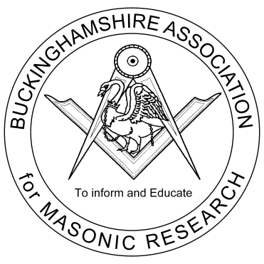
Applicants Full Name:

Address:

Post Code:

Telephone No(s):

Email:

Mobile No:

Craft Masonic Rank:

Lodge(s) Name and No.:

I apply for membership of the Buckinghamshire Association for Masonic Research. I am aware of the annual subscription of £ 8 pa, commencing 1 January, and have applied accepting the special offer of free limited* membership for a limited period, only. (*Transactions in electronic form only)

Signed Date:

Proposer’s Name:

Telephone No(s): Email:

Lodge Name, Province & No:

Proposer's Signature: Date:

Please Note: The proposer should be a subscribing member of the Association or Secretary of the Applicant’s Lodge.

Please send the completed form to:

Bob Chevin - 13 Middle Field, Weston Turville, Aylesbury, Bucks. HP22 5RH

Tel: 01296 613835 Email: ranchmuir@btinternet.com

Page prepared by David J Peck (davepeck@iee.org) – 23Mar2013

